Tool used: SQL Server | Database: Pizza DB

1. **KPI’S**
2. **Total Revenue:**

SELECT SUM(total_price) as Total_Revenue from pizza_sales

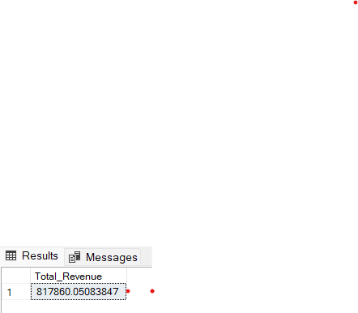

1. **Average order value:**

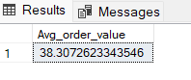SELECT SUM(total_price)/count(DISTINCT order_id) as Avg_order_value from pizza_sales

1. **Total pizza sold:**

SELECT SUM(quantity) as total_pizza_sold

from pizza_sales

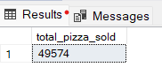

1. **Total order:**

SELECT COUNT(DISTINCT order_id) as Total_order_placed

from pizza_sales

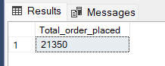

1. **Average pizza per order:**

select cast(cast(sum(quantity) as decimal(10,2)) /

cast(count(distinct order_id) as decimal(10,2)) as decimal(10,2)) as avg_pizza_per_orderid

from pizza_sales

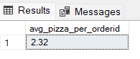

**B. CHARTS**

**1. Daily trend for total orders:**

select DATENAME(DW, order_date) as order_day,

count(distinct order_id) as total_orders

from pizza_sales

group by DATENAME(DW, order_date)

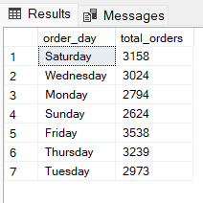

**2. Monthly trend for total orders:**

select DATENAME(MONTH, order_date) as order_month,

count(distinct order_id) as total_orders

from pizza_sales

group by DATENAME(MONTH, order_date)

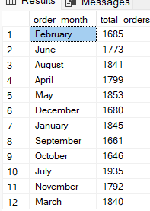

**3. Percentage of sales by pizza category:**

SELECT pizza_category, sum(total_price) *100 / (select sum(total_price) from pizza_sales) AS total_sales

from pizza_sales

group by pizza_category

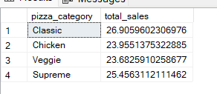

**4. percentage of sales by pizza sales:**

SELECT pizza_size, sum(total_price) *100 / (select sum(total_price) from pizza_sales) AS total_sales

from pizza_sales

group by pizza_size

order by total_sales desc

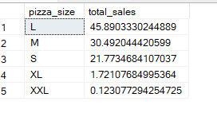

**5. Top 5 best sellers by revenue, total quantity, total orders:**

**--by revenue**

select top 5 pizza_name, sum(total_price) as total_revenue

from pizza_sales

group by pizza_name

order by total_revenue DESC

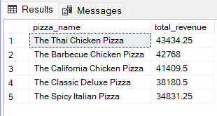

**--by total quantity**

select top 5 pizza_name, sum(quantity) as total_quantity

from pizza_sales

group by pizza_name

order by total_quantity DESC

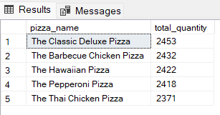

**--by total orders**

select top 5 pizza_name, count(distinct order_id) as total_orders

from pizza_sales

group by pizza_name

order by total_orders DESC

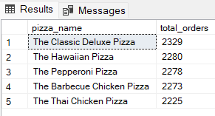

**6. Top 5 worst sellers by revenue, total quantity, total orders:**

**--by revenue**

select top 5 pizza_name, sum(total_price) as total_revenue

from pizza_sales

group by pizza_name

order by total_revenue ASC

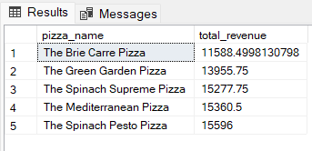

**--by total quantity**

select top 5 pizza_name, sum(quantity) as total_quantity

from pizza_sales

group by pizza_name

order by total_quantity ASC

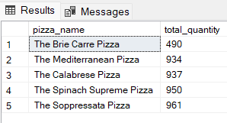

**--by total orders**

select top 5 pizza_name, count(distinct order_id) as total_orders

from pizza_sales

group by pizza_name

order by total_orders ASC

